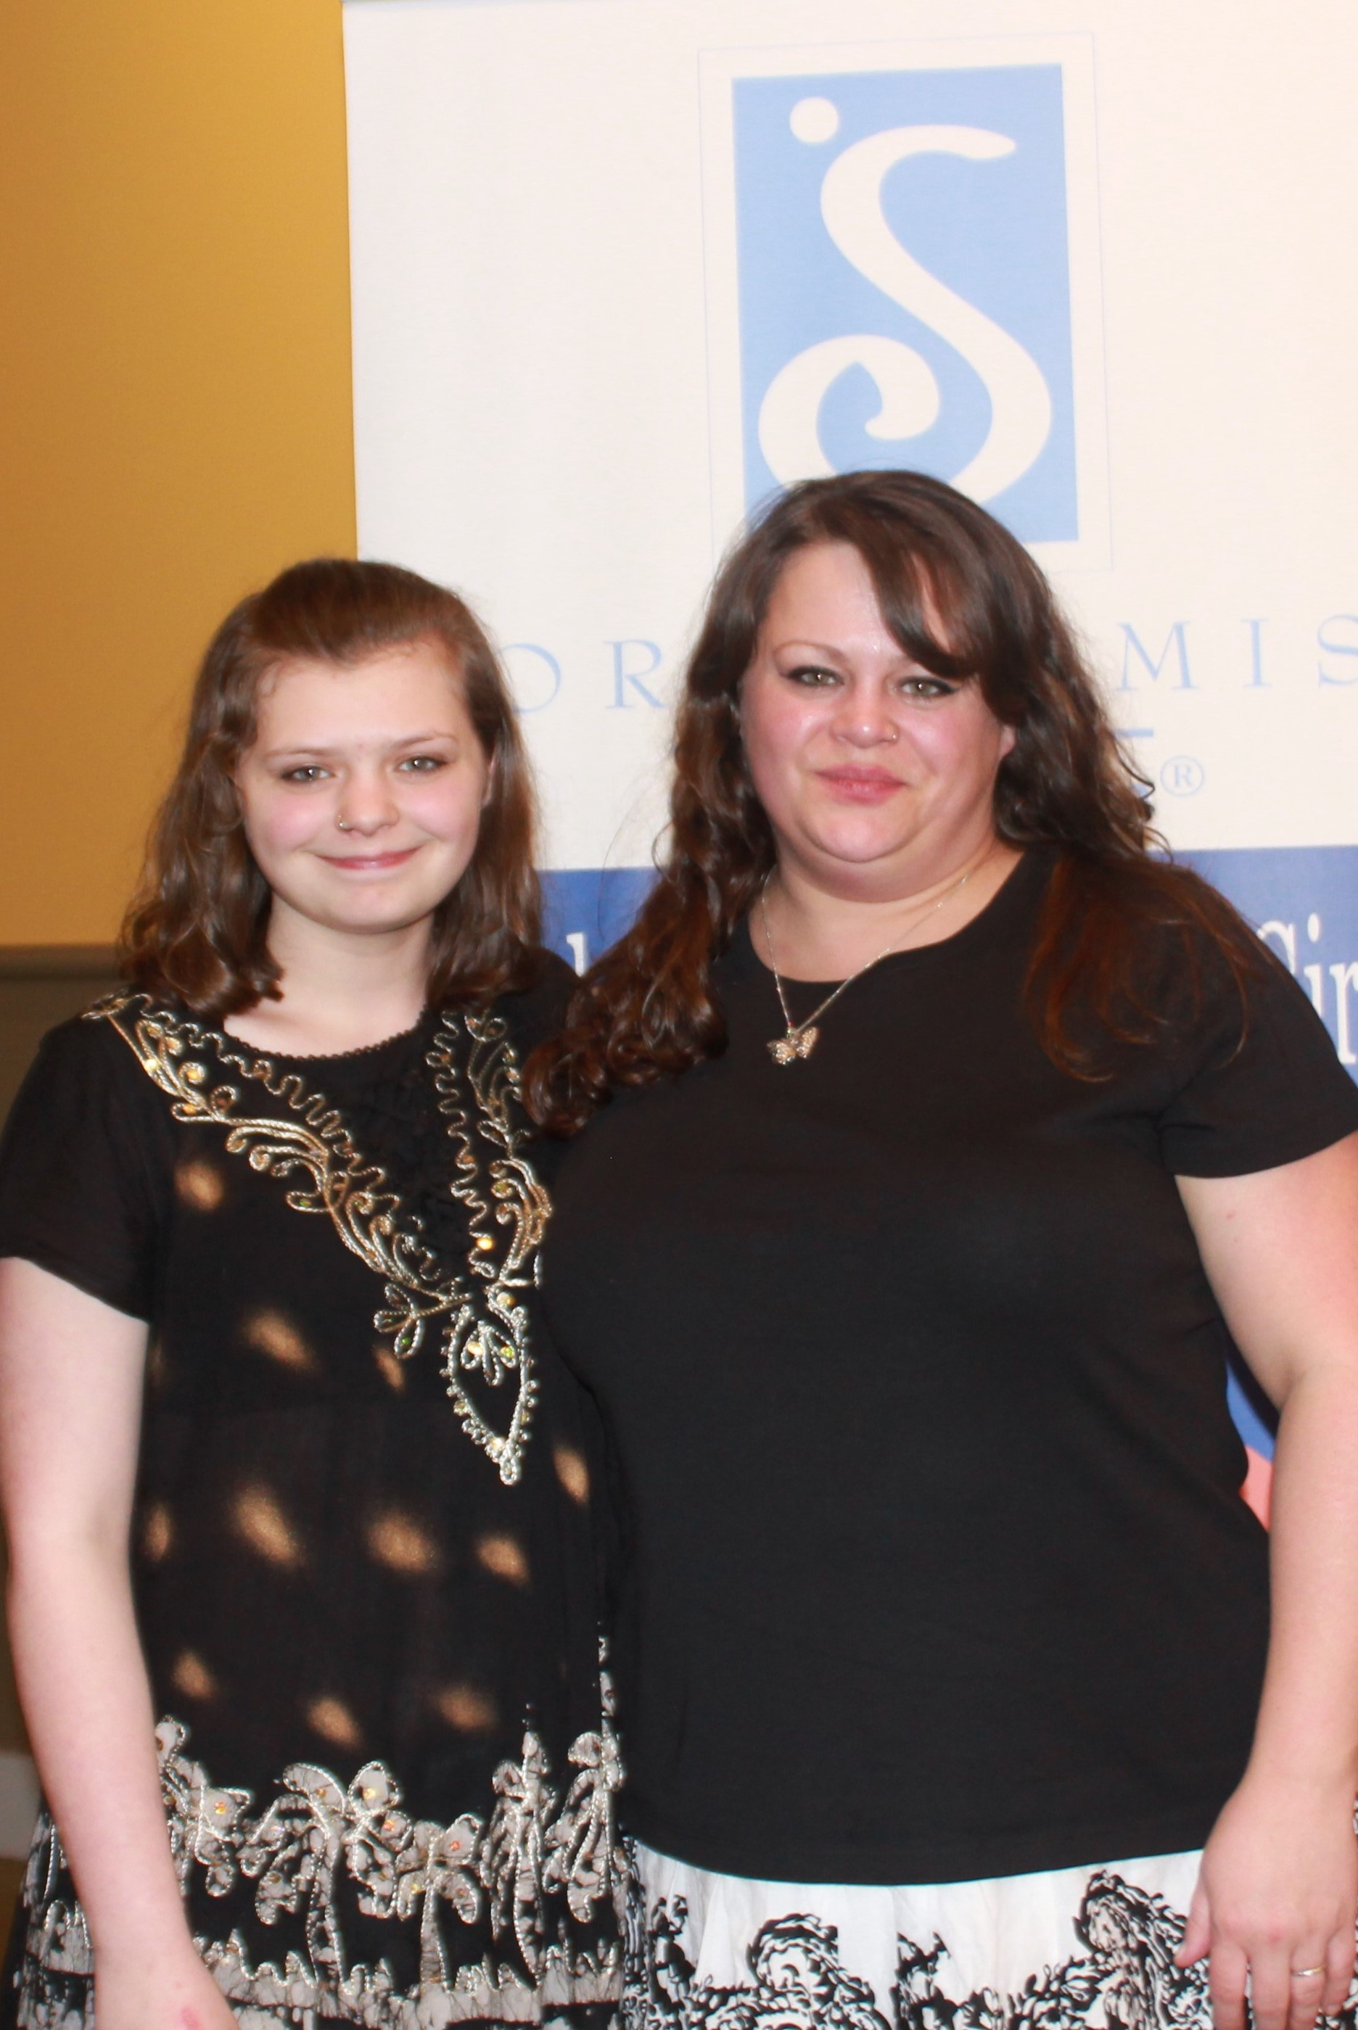  Live Your Dream Award Winner, Nicole, and her daughter.  “I am working very hard to change my situation so one day I can help others too.” Nicole, Live Your Dream Award Recipient Cash Award $1,500  Helping Women to  Live Their Dreams!! |   Dream It Be It Program | Soroptimist  International of  Willimantic  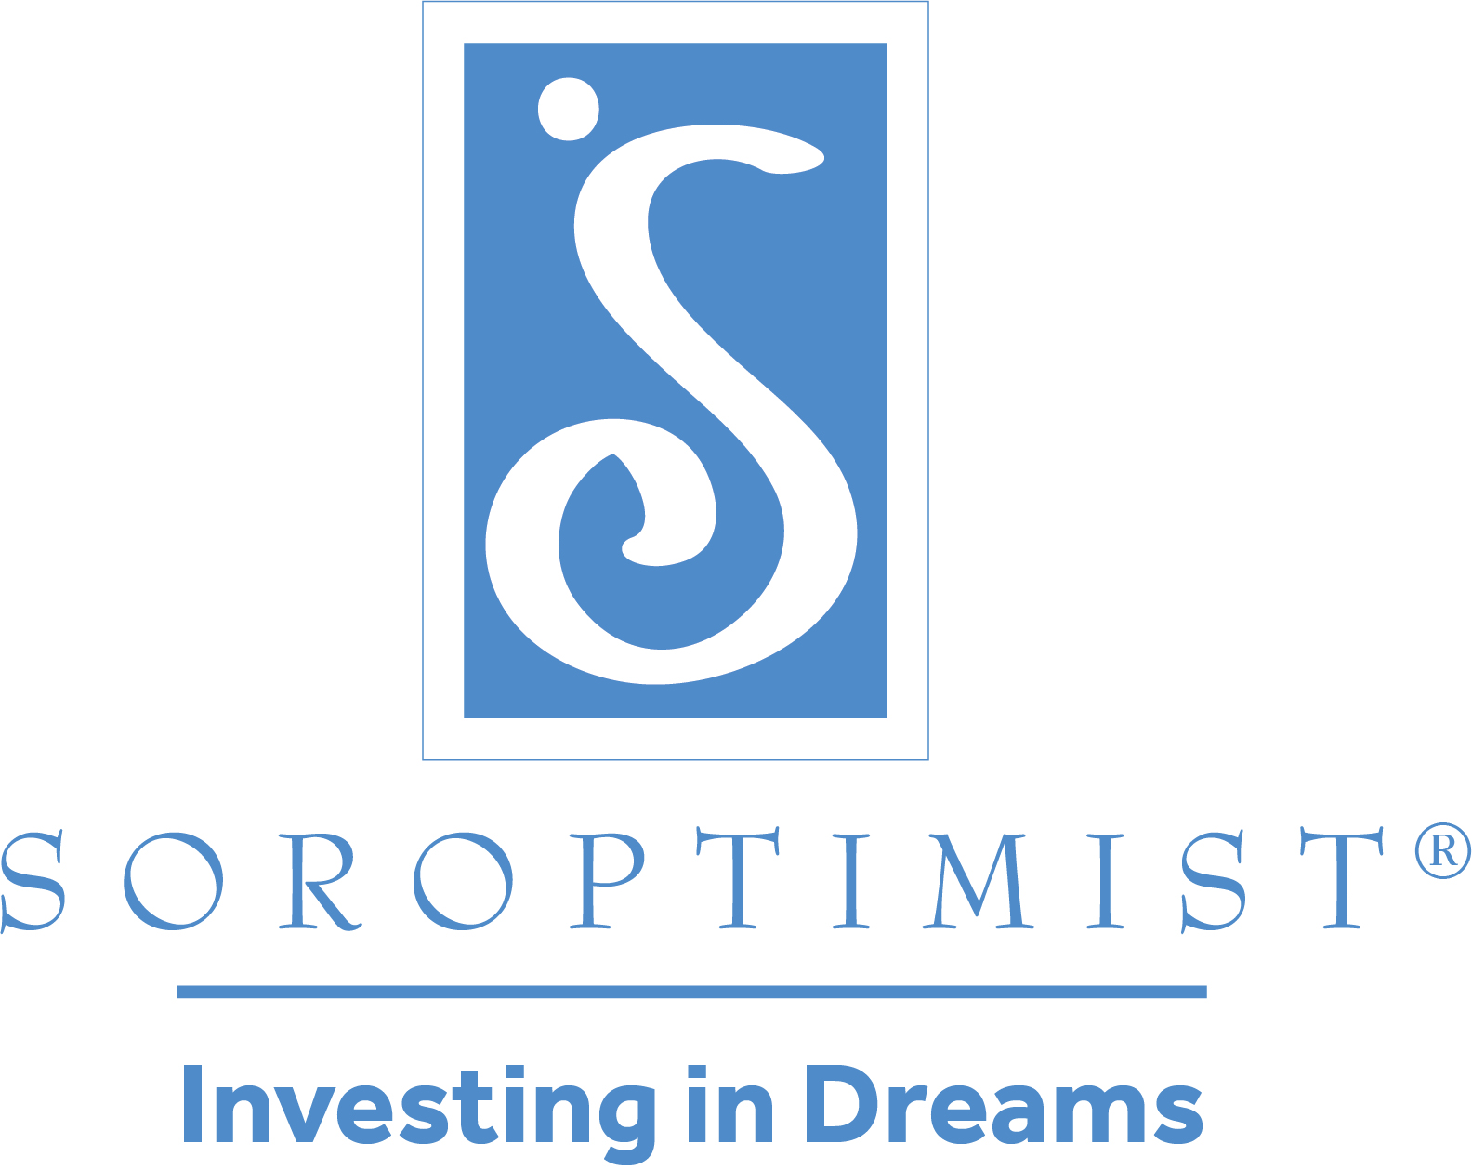  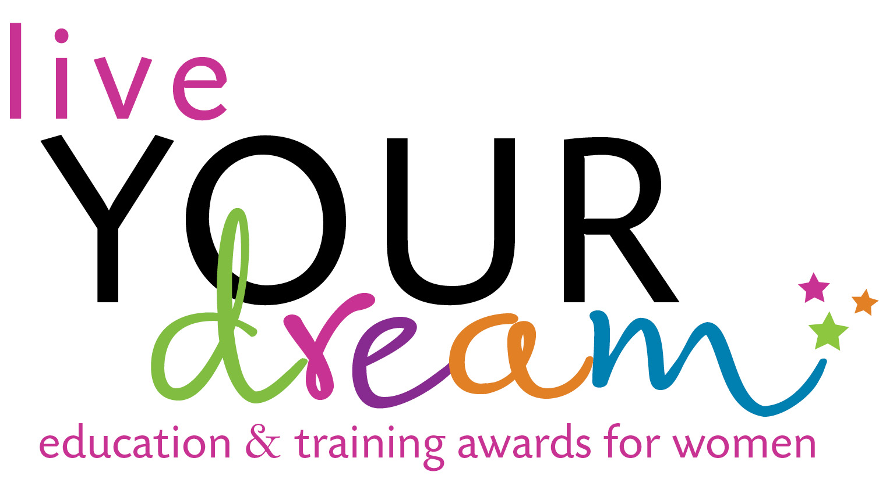  sjdfhfd
  First Saturday in March
  
  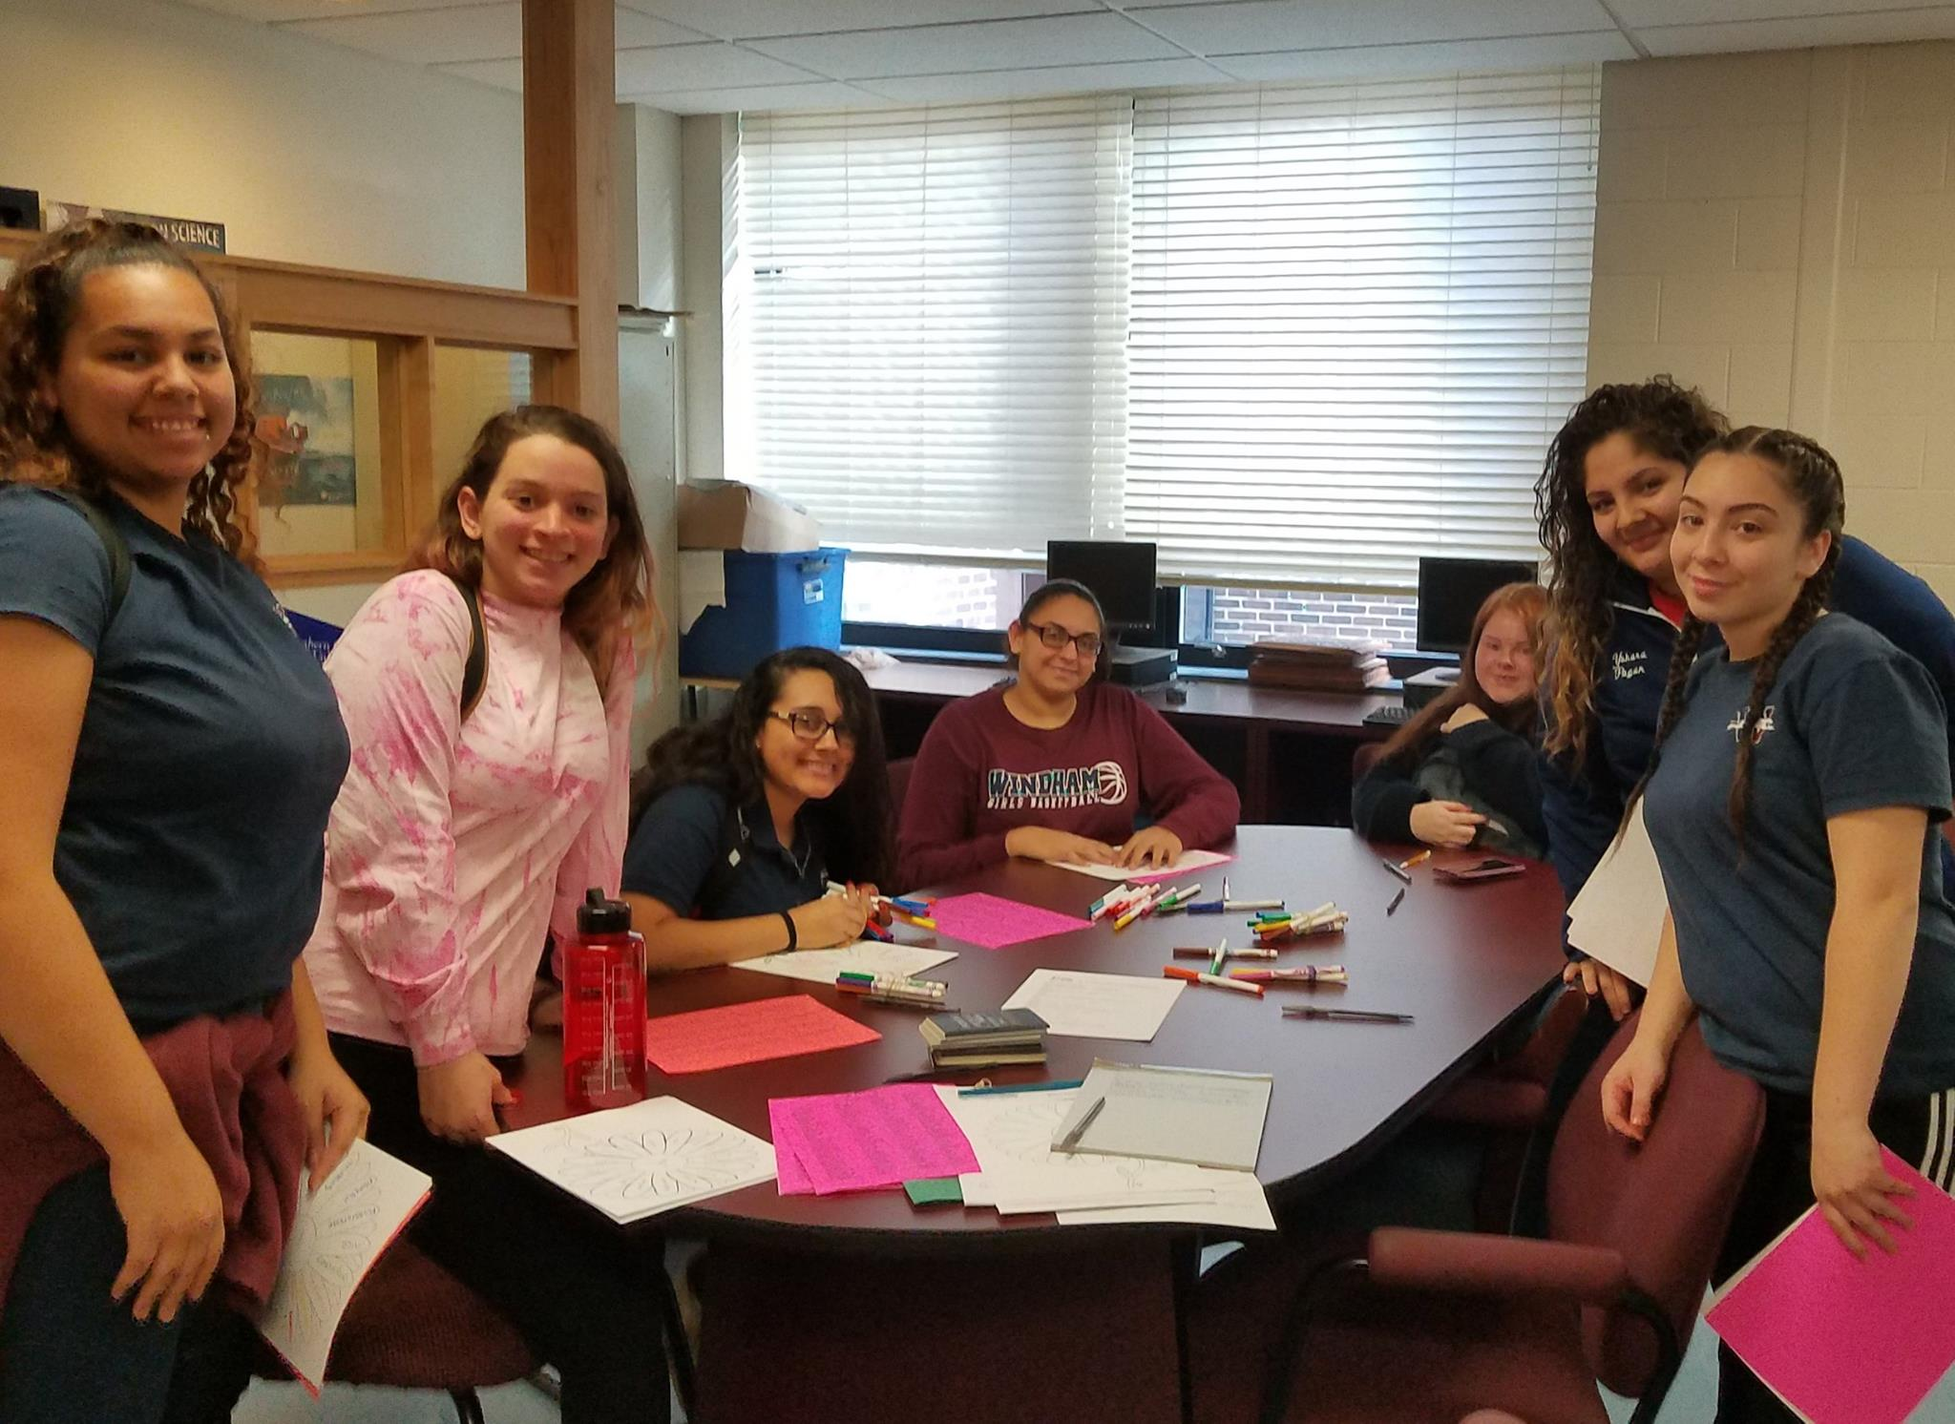
  Soroptimist.org
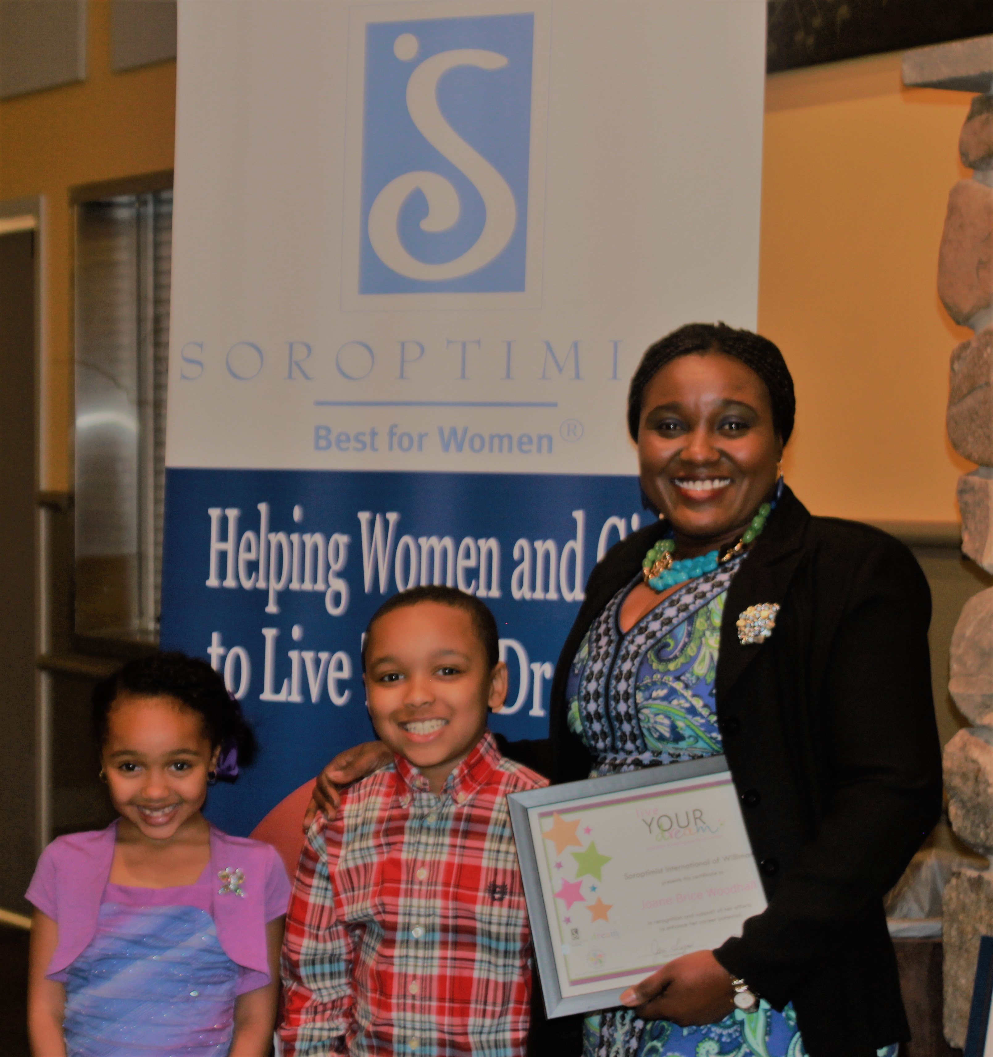  Live Your Dream Award Winner, Joan, and her children.  Mission  Soroptimist is a global volunteer organization that provides women and girls with access to the education and training they need to achieve economic empowerment.  Vision:  Women and girls have the resources and opportunities to reach their full potential and live their dreams.  . | How We Do It  90% of these funds go to the local community while 10% support international programs. In addition to providing women and girls with access to education, members volunteer on local projects such as teaching girls about dating violence and helping to build self-esteem through the Dream It Be It Program  “You all are my inspirations. Soroptimist has inspired me to tell other women to live their dream.” – Joan,  Live Your Dream Award Recipient  Our projects include:  Live Your Dream Award, Grants for Professional Licensing Fees, Domestic Violence Program,  Next Step, Dream It Be It Program for High School Girls, and Take a Stand to End Violence Against Women | Where To Find Us  Website: soroptimistwillimantic.org  Facebook: Soroptimist International of Willimantic  siwillimantic@soroptimist.net  Member Contact: Joan Merritt  860-428-1230  Soroptimist of Willimantic  PO Box 485 Mansfield, CT, 06250  Let’s talk about how you can help us in our mission to improve the lives of women and girls.  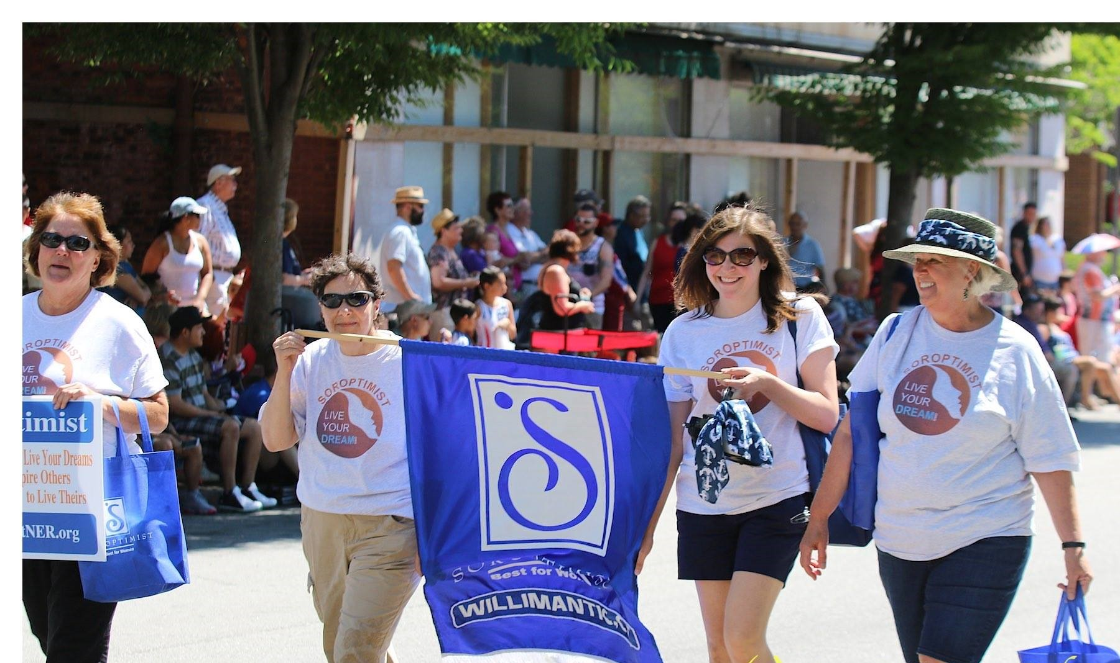  Members march in  Boom Box Parade  What a great community!!

